Assignment Number: | ITB004.17
Assignment Name: | Access Assignment - Part A
Weighting: | 4%
Due Date: | Tuesday 2nd May 2006.  Rather than leaving it to the last minute, you are strongly encouraged to start working on this part of the assignment. The relevant material is covered in lecture 7, in the tutorial and lab sessions that compliment that lecture, and the notes and hints included in the body of the assignment.
Item to be Submitted: | For this part: the AccessAssign061_Videos.mdb database described in the main body of this assignment.
How to be Submitted: | The assignment must be submitted using the Online Assignment System (OAS).

Marking Guide \ Distribution of Marks
The marks shown are weighted marks and so the total of these marks is 4%.
Part marks will be given for a partly correct solution.
A late penalty will automatically be deducted for late assignments following faculty policy (see note (k) for SQL Assignment Part A).

Correct query - minimum number of columns, tables / joins, conditions (as appropriate) 1.00%
Sorting and Grouping – correctly implemented 1.00%
Totalling – correctly implemented 1.00%
General layout – including formatting of data, page numbering etc 1.00%

NB: If you fail to follow the instructions listed in the assignment (in particular see Do’s and Don’ts and Specific instructions) you may not achieve a maximum score despite the otherwise apparent correctness of your solution, i.e. you may lose marks. For example, if you use the wrong name for the report you may lose marks.

The Database and Access Assignments : Parts A, B and C
You are to use the AccessAssign061_Videos.mdb database, for Part A, Part B and Part C of your Access Assignment work.
The AccessAssign061_Videos.mdb database is available on the OLT, it is a Microsoft Office Access 2003 database. This database implements similar tables as referred to in the SQL Assignment, with primary key and foreign key relationships already set. You should refresh your memory of the structure of this database, before attempting the assignment.
Together, the three assignment parts (A, B and C) will form the basis for a complete application. In particular, Part C of the assignment brings together the individual components of the application that you have developed in parts A and B. These assignments are designed to build on the database concepts that you cover in the unit, and give you experience in using the tools (features and facilities) supplied with the commercial database software Microsoft Office Access 2003.

Do’s and Don’ts (for parts A, B and C of your Access assignment)
Before submitting your assignment(s), check that you have met all the requirements listed in this specification. You don’t want to lose marks for things that you think are unimportant, but the marker views differently.

- You are reminded that assignments in ITB004 are not group work (see note (a) for SQL Assignment Part A).

- You must follow all instructions given in the assignment specifications

- You must follow all naming conventions given in the assignment specifications or as indicated in the database provided. For example, you should name the report you create as indicated in the specifications, and you should not change the names of any tables, or fields within tables, provided with the database. Failure to comply with these naming conventions will result in loss of marks, e.g. using different names for your report, or changing the name of any of the tables or fields.

- If your database is too big to be accepted by the OAS, use Access to open it, then use the command Tools → Database Utilities → Compact and Repair Database (as indicated in lectures). After exiting from Access, your database should be small enough to submit. Hint: if you use background pictures for your report or other stylised techniques such as colouring or shadow effects these tend to make the size of the database bigger. It is not recommended you use such effects, and there are no additional marks for doing so. If you experiment with such features it is recommended that you remove them before doing a final compact and repair and then submitting your assignment.

You’ll probably find it helpful to use the actual contents of the database to help you develop your answers. But, as before with the SQL assignments, there are two things to be careful about.

- When writing your queries you must not assume that particular rows are present (or absent) in the database. That is, your queries must still give appropriate results, even if all the current rows were deleted and a completely different set of rows inserted, e.g. if the data were replaced with data concerning different videos.

- The data in the database can be used to help you develop your answers, but there is no requirement to use the given rows in that database, as it is given to you. In particular, there is no guarantee that the data in that database will be sufficient to test whether your answers always work correctly or not.

Some Notes for the Tasks in Parts A, B and C:

- The Wizards will help to get you started on the assignment, but they won’t do all the work for you. Knowing that the Wizards do the basics is taken into account when marking this assignment.

- When developing your report, get it working properly first, and fix up the appearance after that. There is a major reason for this. When working on the layout of a report, it can take quite a while to get all the controls and their labels in the right place, with the right size, fonts, etc. But there can be times when, having made a first attempt at creating a report, you decide that it’s best to throw it away and start again, rather than trying to patch up the mess that you’ve already got. In other words, often when we try to do something, we don’t always succeed first time. But, by trying, we learn more about what we’re supposed to be doing, and are more successful at a second (or third) attempt. When you do this, you then have to redo all the work you put into getting all the controls in the right place, etc. So, leave this until after the report is working.

In this regard, the A&F textbook sets a bad example. In many of their exercises, they get you to start with a form/report created by a Wizard, then fixup the layout straight-away, before adding extra features. This works in the textbook, because the authors know what to do, and never have to throw anything away. You’re not quite in the same situation.

- You are advised to use the Compact and Repair Database feature on a regular basis (Tools → Database Utilities → Compact and Repair Database) (as indicated in lectures). When developing your application the database file can become disorganised and this can cause Access to be unable to work with your database. Using this feature (Compact and Repair Database) will help ensure you don’t lose any work because of this.

The Task
Create the report Stars_Movies_Rentals as shown in Figure1 below, in response to the question and specification following. The figure shown below is a snapshot of the report (in print preview mode). Having different data in the database may make the result of your report differ from that shown in the figure below; for example the movies that each of the stars has appeared in may be different, or the stars may be different. Also, using different fonts etc can influence the layout and number of pages in the report. You are encouraged to try out your report (and other work) by modifying the data in the database, e.g. adding new rows, changing existing rows etc.

The report is intended to give you experience in using report generation tools typically found in a commercial database package. In particular, the assignment tests your knowledge and skills with respect to: Bound, Unbound and Calculated Controls, the RunningSum property, SQL-style summary functions as used in reports, and the IIf function (see Microsoft Office Access Help \ Table of Contents \ Microsoft Visual Basic Documentation \ Visual Basic Language Reference \ Functions \ IIf Function).
[NB: you can use the name of a field as a parameter to the IIf () function. For example, for the field MyField the function call IIf(MyField = 7, “Seven”, “Not Seven”) will return “Seven” if MyField has the value 7 and return “Not Seven” if MyField does not have the value 7 (assuming no nulls). In addition, you can use an SQL-style summary function as a parameter to the IIf () function, for example IIf(Avg([MyField])>10, Avg([MyField]), “Avg is less than 10”)].

The basic purpose of the report is to answer this question:
What movies, and how many movies, has each star appeared in, how many times has each such movie been rented, and when was it last rented?

Special Note:
Remember, not all copies of movies have been rented, but we want to know about all the movies a star has appeared in, as indicated in the figure.

The finer details (see Figure1):

- The title of the report is “Stars_Movies_Rentals”. The date at which the report is previewed appears next to the title. This is followed by the page header in which the content of the data columns is labelled.

- For each star, show all the movies in which the star appears, including the number of rentals of each movie and the most recent date it was rented (see point 4), and show the total number of movies in which each star appears.

- For each star, before the list of movies in which they appear show their given name followed by a single space followed by their family name. Following the list of movies in which the star appears show the name of the star (as before) followed by a single space then the total number of movies in which they appear enclosed in parenthesis then a single space and then either “movie” (singular) or “movies” (plural) as appropriate. Immediately following the details of each star, show a line across the page.

- For each movie, show the title of the movie followed by a single space and the year the movie was released enclosed in parenthesis. For example “Mad Max (1979)”. Following this, show the number of rentals for each movie and the most recent date it was rented (NB: assume the DueDate is the date a movie is rented). Note the format of this date. If the movie has not been rented show “n/a” against the number of rentals and leave the most recent date blank.

- Indicate the end of the report using the words “The END”

- At the end of each page, the page number and total number of reported pages should appear, as indicated in the figure.

Specific instructions (Read Carefully!):

- You must use a query as the source of data for your report (not a SelectStatement) – see Lecture 7, Slide 45.

- You must not use sub-queries in your query.

- You must not use group by in your query.

- You must not use any SQL-style summary functions or Domain Aggregate functions in your query.

- You must not use nested queries in your query. In other words, you must not use a query in the FROM clause of another query.

- You must use the Sorting and Grouping feature for your report.

- You must not use a subreport feature for your report.

- You must name your report: Stars_Movies_Rentals.

- You must name your query: Stars_Movies_Rentals.

- Think carefully about what is in your query, before creating your report.

- Your query should have the minimum number of columns necessary for the report.

- Your report should be as shown in the figure at the end of this specification.

Moving Your Work to Another Copy of the Database
Having everything in a single (.mdb) file makes some things easier and some things harder. If you muck up some of the rows in one or more of the tables, and want to restart with a fresh copy from the original database, this can be done, if you’re careful. If you destroy some rows and haven’t got very far in doing this assignment, then the easiest way is to start again with an entirely fresh copy of the original database. But, if you want to keep your queries/reports/etc, then here’s one way to do it.

- Close your database and exit the Access application.

- Rename your existing database to some other name, e.g. Old.mdb.

- Get a fresh copy of the original database (e.g. from the OLT).

- Open your new/fresh copy of the database; Select the menu command File → Get External Data → Import, then select the name of your old database and click the Import button. The Import Objects dialog box appears.

- Select the tab for the type of objects that you wish to copy from the old database (e.g. Queries). Then select the items that you want to copy. Don’t click on Ok just yet.

- Repeat step 4 for any other types of objects that you want, i.e. forms & reports.

- Click on Ok. The objects will be imported and will appear in the Database Window.

- Keep your old database in a safe place. You never know – you might want to use it again (if things go badly).

Figure1:
NB: Remember, the figure shown below is a snapshot of the report (in print preview mode). Having different data in the database may make the result of your report differ from that shown in the figure below.

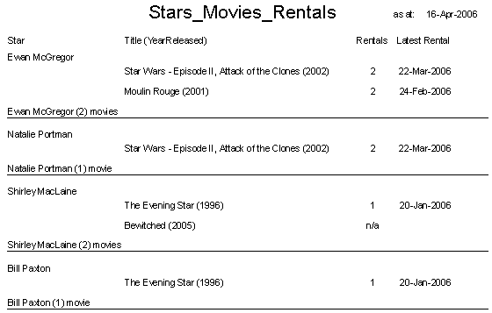

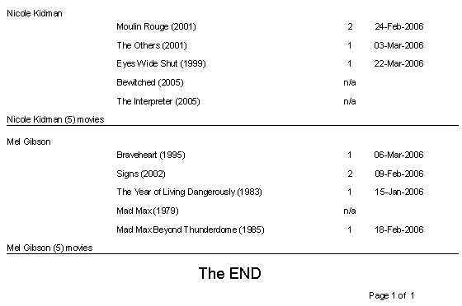

End of Assignment Specification.

